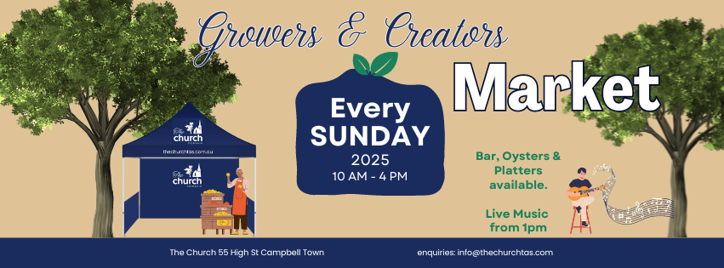

## **Musicians Application/Booking Form**

## Perform at The Church 55 High St Campbell Town Tasmania

## Performers: Every Sunday 1pm to 4pm.

## Website: www.thechurchtas.com.au

## Performance Details:

Performance Time: Sundays, 1:00 PM – 4:00 PM (3 hours) with max 2 x 15 min breaks.

Location: Outdoors in good weather, Inside The Church in poor weather

Venue: The Church, 55 High St Campbell Town, Tasmania

## Artist Information

Name of Artist/Band:

Business Name:

ABN:

Contact Person:

Phone Number:

Email Address:

Website (if applicable):

YouTube Link (essential):

Social Media Links (if applicable):

Genre/Style of Music:

Number of Performers in Group:

Instruments and Equipment Used:

Please list your requested/available Sundays in 2025

Payment Terms and Conditions:

Performances are scheduled for 3 hours (1:00 PM – 4:00 PM with max 2 x 15 minute breaks).

Your fee?

Payment will be discussed and confirmed upon booking.

The Church will provide a Stage, Electricity, Stool and Large Umbrella for outdoors in good weather or inside The Church in poor weather.

Do you have any special requirements for your performance?

Any additional comments or questions?

Terms & Conditions:

* Setup and Equipment: Performers are responsible for providing their own equipment and lighting and any other necessary equipment unless previously arranged with the venue. Electricity will be provided.
* Payment: Payment terms will be discussed and agreed upon before the performance. Any additional fees (e.g., travel or accommodation) must be negotiated in advance. Payments will be made upon completion of the performance unless otherwise agreed.
* Weather Policy: In the event of poor weather, performances may be moved indoors. If the event is cancelled due to extreme weather conditions, the performer will be notified as soon as possible.
* Cancellations: Performers must give at least 7 days' notice if they are unable to perform. Failure to provide adequate notice may result in forfeiture of payment or future booking opportunities.
* Behaviour and Conduct: Performers must conduct themselves in a professional manner at all times. The Church reserves the right to cancel a performance or ask performers to leave the venue if they fail to behave appropriately or follow venue rules. This is a family venue so no swearing or inappropriate content will be tolerated.
* Insurance: Performers are responsible for their own public liability insurance and insurance for their equipment. The Church is not responsible for any loss or damage to equipment or personal belongings during the event.
  + Please attached Certificate of Personal Liability Insurance
* Promotion: Performers agree to allow The Church to use their name, photos, videos, and performance details for promotional purposes on social media, websites, and other marketing materials. Performers are encouraged to promote their performance through their own channels as well.
* Licensing: Performers are responsible for ensuring that their music complies with copyright laws. The performer must have the necessary licenses for cover songs or other copyrighted material.
* Health and Safety: Performers are expected to follow all health and safety regulations provided by the venue, including those related to equipment setup and sound levels.
* Liability: The Church is not liable for any injury, illness, or damage caused during the performance, except in cases of gross negligence by the venue.

Declaration:

I, the undersigned, agree to the terms and conditions set by The Church Tas Pty Ltd and confirm that all the information provided in this application is accurate.

Signature:

(electronic signatures are OK if you send from the email address you have listed above)

Date:

Please save as a PDF and submit your application via email: info@thechurchtas.com.au

Don’t forget to attach Certificate of Liability Insurance and any other relevant information you wish to provide.

Thank you for your interest.